Planting Peace

Words and music for a New World

With Will Tuttle

Join us for an evening of original music and a lecture on
Dr. Tuttle’s acclaimed best-seller, The World Peace Diet

The World Peace Diet, a #1 Amazon best-seller, has been called one of the most important books of the 21st century: the foundation of a new society based on the truth of the interconnectedness of all life.
“A master at recreating the deepest vibrations of the soul,” Will Tuttle’s inspiring original piano music evokes deep feelings and a sense of wonder and adventure.
Come and expect to be transported, uplifted, and carried to new inner places!

“When playing the piano, he works from his Buddha-nature, floating, not trying, beyond mistakes.” Joseph Campbell, noted mythologist and writer
“Use The World Peace Diet as a guide to empower yourselves and others in making dietary choices that are powerful beyond what you can possibly imagine.”
Julia Butterfly Hill, noted environmental activist and author
“A profoundly insightful and important book, The World Peace Diet is sure to be a catalyst and powerful tool in the evolution of human consciousness.” Satya Magazine
“The sounds of harmony and peace fill the heart when listening to Will Tuttle’s music. He is a master at recreating the deepest vibrations of the soul.”
Michael Toms, founder, New Dimensions Radio

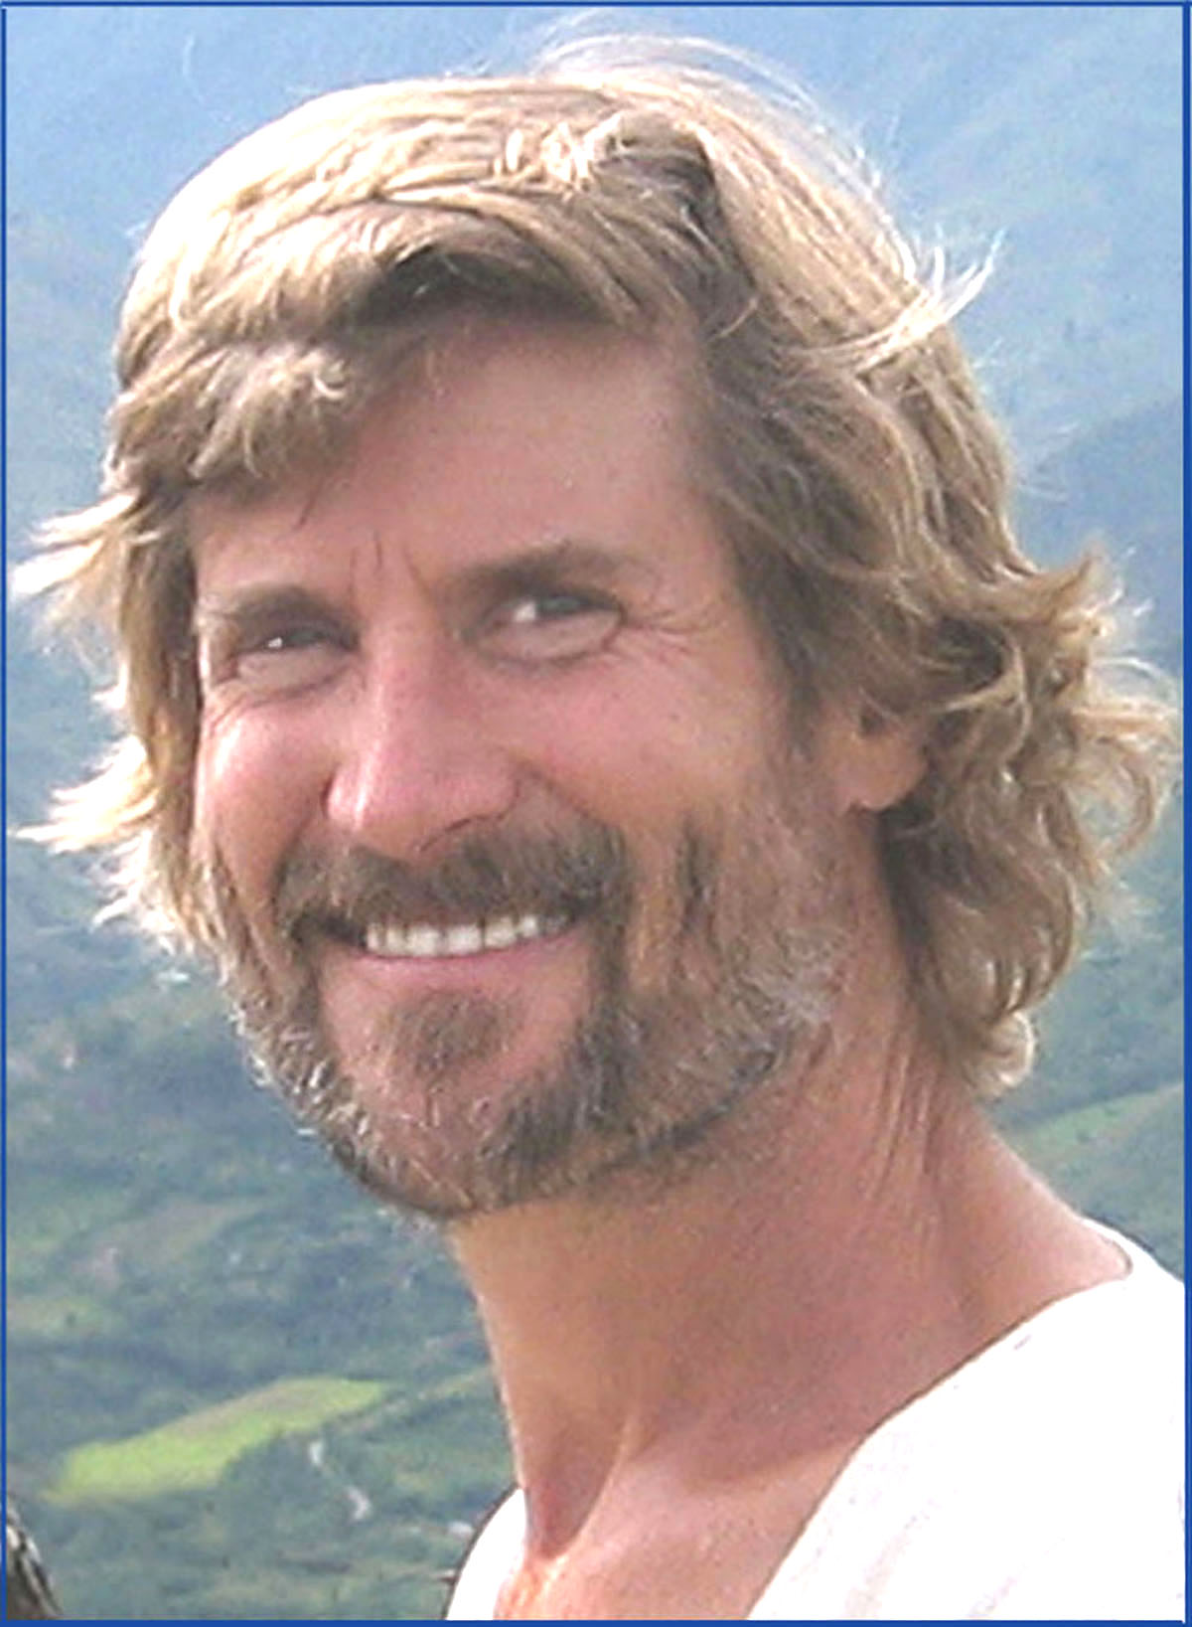

Dr. Will Tuttle, best-selling author, educator, pianist, and composer, has lectured and performed widely throughout North America and Europe. His doctorate degree from the University of California, Berkeley, focused on educating intuition in adults, and he has taught college courses in creativity, humanities, mythology, religion, and philosophy. He is a recipient of The Peace Abbey’s Courage of Conscience Award and is a Dharma Master in the Zen tradition. Devoted to cultural healing and awakening, he has created 7 much-loved CD albums of original piano music, and also his ground-breaking book, The World Peace Diet. He is noted for his clear and inspiring presentations, which often include inspiring animal paintings by his spouse, Madeleine, a visionary artist. See www.worldpeacediet.org for more details.

