Planting Peace
Words and music for a New World

With Will Tuttle

Join us for an evening of original music and a lecture on Dr. Tuttle’s uplifting book, The World Peace Diet

The World Peace Diet has been called one of the most important books of the 21st century: the foundation of a new society based on the truth of the interconnectedness of all life.
“A master at recreating the deepest vibrations of the soul,” Will Tuttle’s inspiring original piano music evokes deep feelings and a sense of wonder and adventure.
Come and expect to be transported, uplifted, and carried to new inner places!

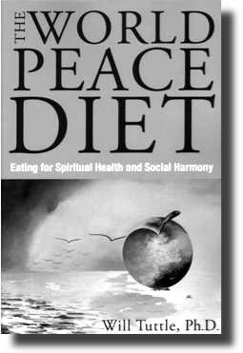
“When playing the piano, he works from his Buddha-nature, floating, not trying, beyond mistakes.” Joseph Campbell, noted mythologist and writer
“Use The World Peace Diet as a guide to empower yourselves and others in making dietary choices that are powerful beyond what you can possibly imagine.” Julia Butterfly Hill, environmental activist and founder, Circle Of Life Foundation
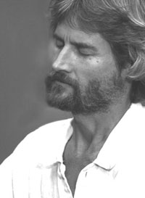
“A profoundly insightful and important book, The World Peace Diet is sure to be a catalyst and powerful tool in the evolution of human consciousness.” Satya Magazine
“The sounds of harmony and peace fill the heart when listening to Will Tuttle’s music. He is a master at recreating the deepest vibrations of the soul.”
Michael Toms, founder, New Dimensions Radio
Planting Peace
Words and music for a New World

With Will Tuttle

Join us for an evening of original music and a lecture on Dr. Tuttle’s uplifting book, The World Peace Diet

The World Peace Diet has been called one of the most important books of the 21st century: the foundation of a new society based on the truth of the interconnectedness of all life.
“A master at recreating the deepest vibrations of the soul,” Will Tuttle’s inspiring original piano music evokes deep feelings and a sense of wonder and adventure.
Come and expect to be transported, uplifted, and carried to new inner places!

“When playing the piano, he works from his Buddha-nature, floating, not trying, beyond mistakes.” Joseph Campbell, noted mythologist and writer
“Use The World Peace Diet as a guide to empower yourselves and others in making dietary choices that are powerful beyond what you can possibly imagine.” Julia Butterfly Hill, environmental activist and founder, Circle Of Life Foundation
“A profoundly insightful and important book, The World Peace Diet is sure to be a catalyst and powerful tool in the evolution of human consciousness.” Satya Magazine
“The sounds of harmony and peace fill the heart when listening to Will Tuttle’s music. He is a master at recreating the deepest vibrations of the soul.”
Michael Toms, founder, New Dimensions Radio

