Individual Sessions

For Personal Music & Art

With

Dr. Will and Madeleine Tuttle
T

hese sessions can be for either individuals or couples.

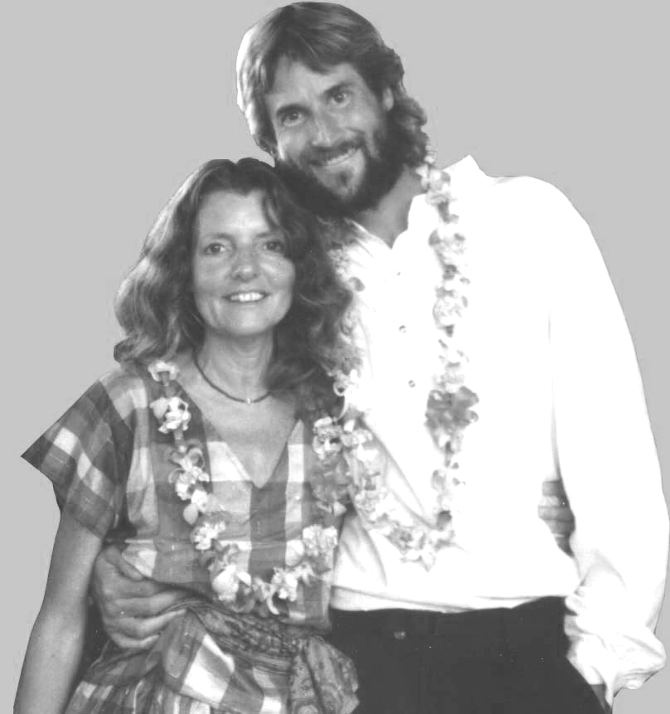
SIn your session, Will meditatively tunes into your unique essence and translates this into music. You will receive a private piano concert inspired by your spirit, and the music is recorded onto a 30-minute CD and a digital master.
Wimultaneously, Madeleine creates a 9” x 12” watercolor painting also inspired by your essence, not a physical likeness but a unique artistic blend of evocative images.
Pill and Madeleine have been creating individualized Music & Art Portraits over 10 years and are the only ones providing these unique, uplifting, healing, and evocative creations. People are consistently deeply touched by them.
lease see Will and Madeleine at their table for more details or to schedule an appointment! The suggested donation is $135 and the sessions last approximately 45 minutes.
Individual Sessions

For Personal Music & Art

With

Dr. Will and Madeleine Tuttle
TT

hese sessions can be for either individuals or couples.

SIn your session, Will meditatively tunes into your unique essence and translates this into music. You will receive a private piano concert inspired by your spirit, and the music is recorded onto a 30-minute CD and a digital master.

Wimultaneously, Madeleine creates a 9” x 12” watercolor painting also inspired by your essence, not a physical likeness but a unique artistic blend of evocative images.

Pill and Madeleine have been creating individualized music & Art Portraits over 10 years and are the only ones providing these unique, uplifting, healing, and evocative creations. People are consistently deeply touched by them.
lease see Will and Madeleine at their table for more details or to schedule an appointment! The suggested donation is $135 and the sessions last approximately 45 minutes.

