Healing our World: A Deeper Look at Food

The World Peace Diet
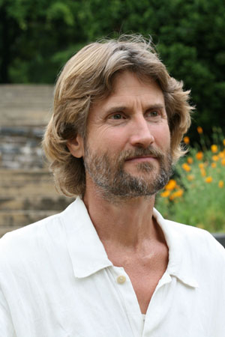

A lecture - presentation by

Will Tuttle, Ph.D.

Author of the best-seller The World Peace Diet, Dr. Will Tuttle delivers an inspiring talk about the hidden dimensions of our culture’s food system. You will discover new connections and learn how to make positive changes that nurture wellness, awaken compassion and awareness, promote justice, and bring healing to our world.

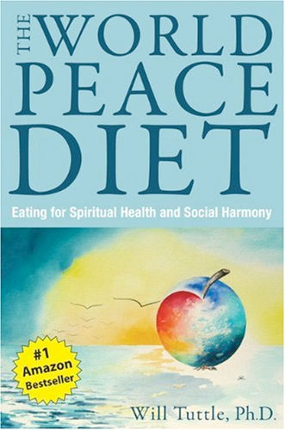
“I've never seen an audience so attentive and enraptured as when Will Tuttle speaks.” - Tench Phillips, president, Art Repertory Films, Norfolk, VA
“Use The World Peace Diet as a guide to empower yourselves and others in making dietary choices that are powerful beyond what you can possibly imagine.”
- Julia Butterfly Hill, environmental activist and noted author
“Dr. Will Tuttle is an inspirational force. The energy and expressions that I witnessed in the room around me were monumental.” - Jerrilyn Halbert, KPFT Radio, Houston

“The World Peace Diet is one of the most provocative books I’ve ever read. This is a deep book, aglow with insights that penetrate and expose the complacency of a culture that has strayed painfully far from compassion.” - John Robbins, noted author

Dr. Will Tuttle, visionary author of the international best-seller, The World Peace Diet, published in 16 languages, has lectured and performed widely throughout North America and worldwide. A featured expert in Cowspiracy and other documentary films, his doctorate degree from U.C., Berkeley, focused on educating intuition and altruism, and he has taught college courses in creativity, comparative religion, and philosophy. He’s a recipient of the prestigious Courage of Conscience Award and is a former Zen monk and Dharma Master in the Zen tradition. Editor of Circles of Compassion: Connecting Issues of Justice, and creator of 7 much-loved CD albums of original piano music, he’s noted for clear and inspiring presentations that often include his music as well as evocative animal paintings by his spouse, Madeleine, a visionary artist from Switzerland. See www.worldpeacediet.com for more details.

