Opening the Intuitive Gate
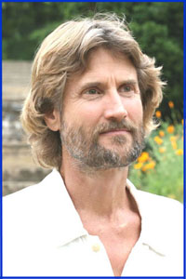

The Keys to
Developing Your Intuition
with
Will Tuttle, Ph.D.
An acclaimed pianist, composer, and author, Will Tuttle unites both eastern and western meditation traditions and is a Dharma Master in the Zen tradition.
Uplifting, philosophical, musical, and both challenging and reassuring, this is a workshop that can change lives, as we invite spirit to work its wonders on the ultimate frontier: the human heart.

Dr. Tuttle’s insights include:
- Discovering your unique ways of accessing your intuitive wisdom
- Effective inner & outer practices for developing joy and spiritual awareness
- Techniques using meditation, imagery, music, and art that inspire intuitive insights
- How to respond to the global “intuitive imperative” and meditate more effectively
- Ancient secrets for awakening the love, compassion, joy, and peace within.

Will Tuttle, pianist, composer, educator, and author, has performed and lectured widely throughout the United States and Europe. His doctorate degree with highest honors from the University of California, Berkeley, focused on educating intuition in adults, and he has taught college courses in creativity, humanities, mythology, and philosophy. He has a broad background in both Eastern and Western meditation traditions, and is a former Zen monk. Devoted to planetary awakening and to creating uplifting healing music, he has created 8 much-loved CD albums of original piano music, as well as his #1 Amazon best-selling book, The World Peace Diet. He currently travels with his spouse, Madeleine, a visionary artist from Switzerland, providing concerts, lectures, workshops, and exhibits, and their intuitively-inspired Personalized Music and Art Portraits for individuals and couples.

