Piano Passion
Concert for World Peace

The Uplifting & Healing Music of

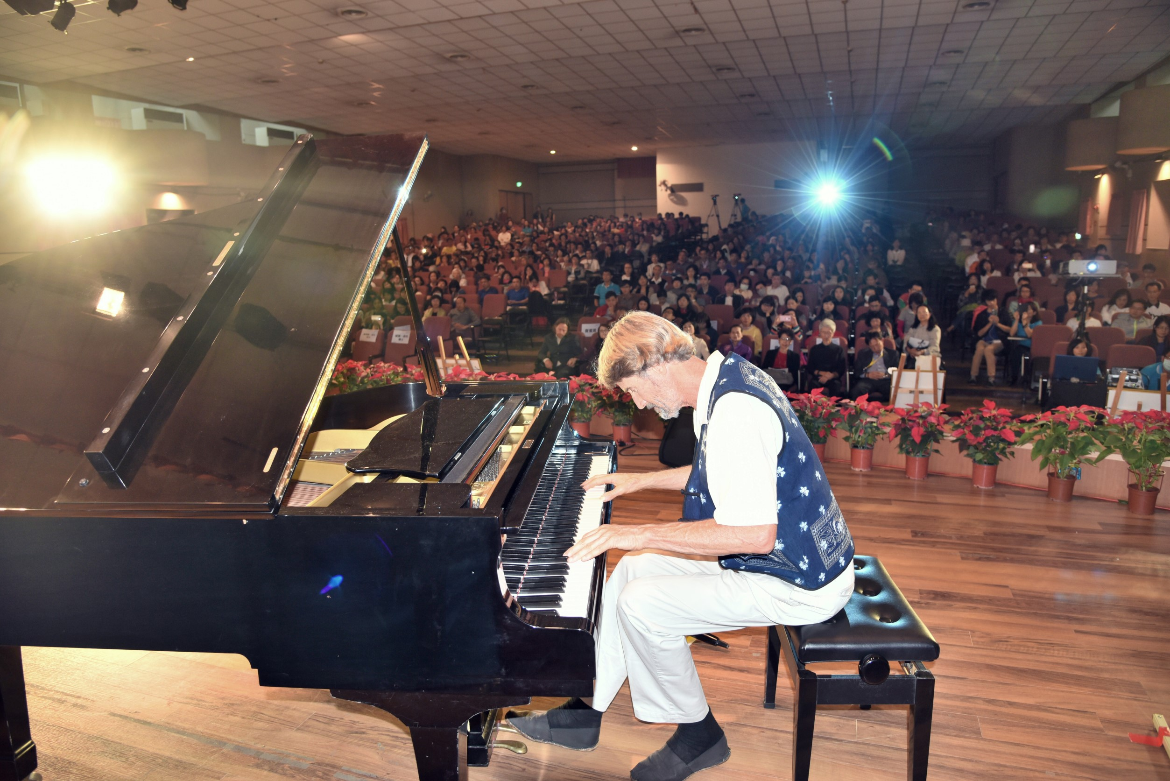
Will Tuttle

“A master at recreating the deepest vibrations of the soul,” Will Tuttle’s uplifting original piano music evokes deep feelings and a sense of wonder, joy, and adventure.
An acclaimed pianist, composer and recording artist, as well as a Dharma Master in the Zen tradition, Dr. Tuttle has performed widely throughout North America and worldwide for the past 30 years, and has created 8 beloved CD albums of all-original piano music.
This Piano Passion Concert is an affirmative musical invocation for world peace and for celebrating the beauty of the Earth and potential of our Spirit. Rooted in ancient sacred traditions that see music as a vehicle of consciousness, the concert generates a field of healing and awareness. It includes visionary art by Will’s spouse, Madeleine, who is a nature artist and flautist from Switzerland, as well as accompaniment by Madeleine on several pieces on silver flute.
Come and expect to be transported, uplifted, and carried to new inner places!
“When playing the piano, he works from his Buddha-nature, floating, not trying, beyond mistakes.”
Joseph Campbell, noted mythologist and writer
“Will Tuttle has the amazing ability to play spontaneous meditational music that is truly uplifting. He has a unique style of his own, and he and the piano seem to become one in pouring forth melodious, uplifting music.” Peter Caddy, Co-Founder of Findhorn Community, Scotland

“Stirring, heart-opening, inspiring, he takes solo acoustic piano into a new dimension, inviting us to explore the far reaches of our imaginations and soar into the fresh dawn of a new day. My highest recommendation.” Edge Ryals, New Age Retailer magazine
“The sounds of harmony and peace fill the heart when listening to Will Tuttle’s music. He is a master at recreating the deepest vibrations of the soul.” Michael Toms, founder, New Dimensions Radio

This concert is offered for freedom, for Earth-healing, and for the happiness of every being.

